Hi Dr. ____,

Thank you for your recent TeleVox purchase! My name is ____ and I will be your contact for the implementation of the new responsive Starter website. I wanted to go ahead and email over the information you will need to get started.

To begin, please visit our online survey at: <https://www.televox.com/website/site-survey/> which will help us to develop content and collect images to make your website unique. We have found that most clients are able to complete the survey and submit it to us within 7 days, which helps us stay on track in getting your new website created and on the live domain as quickly as possible.

We recently designed four new Starter layouts. Click on the names under each image below to view them:

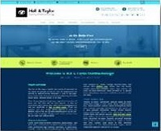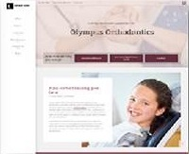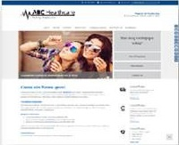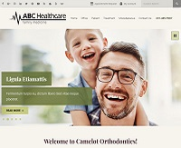

[Neverland](http://startertest.televox.west.com/) [Olympus](http://olympusbasetest.televox.west.com/) [Atlantis](http://atlantisbasetest.televox.west.com/) [Camelot](http://camelotbasetest.televox.west.com/)

You also get to choose a color palette, fonts and a few other options. Although our Starter layouts are pre-designed, we still have to develop them out individually and add your personal information to them. So keep that in mind as you choose a layout, color palette and fonts. Once the site moves into our development phase, we are not able to change the layout, color palette or fonts that were first chosen.

* Choose from 18 color palettes:
  + Neverland: <http://startertest.televox.west.com/miscellaneous/customization/predesigned-color-palettes>
  + Olympus: <http://olympusbasetest.televox.west.com/miscellaneous/customization/predesigned-color-palettes>
  + Atlantis: <http://atlantisbasetest.televox.west.com/miscellaneous/customization/predesigned-color-palettes>
  + Camelot: <http://camelotbasetest.televox.west.com/miscellaneous/customization/predesigned-color-palettes>
* Choose from 13 font options:
  + Neverland: <http://startertest.televox.west.com/miscellaneous/customization/font-options>
  + Olympus: <http://olympusbasetest.televox.west.com/miscellaneous/customization/font-options>
  + Atlantis: <http://atlantisbasetest.televox.west.com/miscellaneous/customization/font-options>
  + Camelot: <http://camelotbasetest.televox.west.com/miscellaneous/customization/font-options>
* Several options for call outs and features on the homepage:
  + Neverland: <http://startertest.televox.west.com/miscellaneous/customization/homepage>
  + Olympus: <http://olympusbasetest.televox.west.com/miscellaneous/customization/homepage>
  + Atlantis: <http://atlantisbasetest.televox.west.com/miscellaneous/customization/homepage>
  + Camelot: <http://camelotbasetest.televox.west.com/>

*\*Please let me know which layout, fonts and color palette you would like so that I can send you the appropriate sign-off form.*

Attached you will find our Starter Implementation Guide. Keep this document handy and feel free to reference it throughout the duration of the implementation process. It outlines features included in your package, terms to know, what you can expect and key points where we will need your input.

Once we receive the completed survey we will begin developing your new website. Also, please send me a digital copy of your logo (eps or ai format) so that we can include it in the new website, as well as photos of your office and/or team. Once the development phase is over we will provide a preview link to you where you will have access to make changes to your content and images. Please don’t hesitate to email or call if you have any questions. I look forward to working you on this new website project and hearing from you soon!

I look forward to working with you on your new website and hearing from you soon! Thank you,